|  |
| --- |
| **Task 1: screen sketches** |

1. Setting Goal

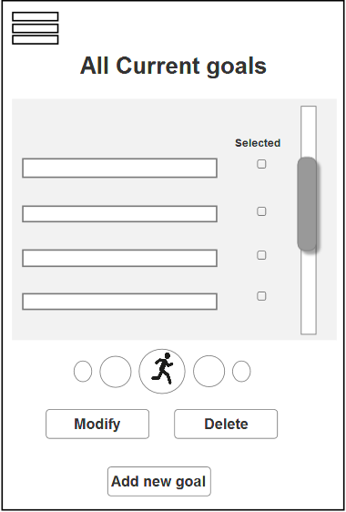

A-1 i

Figure 1.1

This screen shows all the goals set by user (No goals for new user)

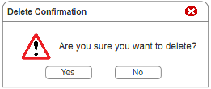

A-1 ii

Figure 1.2

This message is prompted to ask if user confirms to delete the selected goal(s).

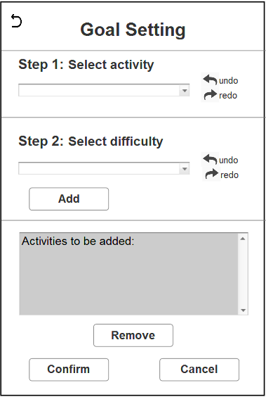

#A-3

#A-4

A-4 & #A-5

A-1 I & #A-6

A-2

Figure 1.3

This screen is shown when user presses the “Add new goal” button.

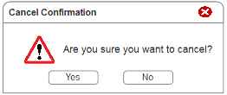

A-1 ii

Figure 1.4

This message is prompted to ask if user confirms to cancel the progress.

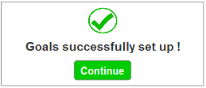

A-3

#A-2

Figure 1.5

This message is shown when user successfully set goal(s).

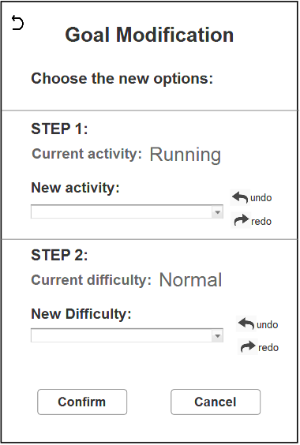

#A-4

#A-3

A-1 I & #A-6

A-2

A-4 & #A-5

Figure 1.6

This screen is shown when user presses the “Modify” button to modify selected goal.

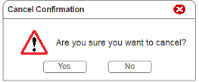

A-1 ii

Figure 1.7

This message is prompted to ask if user confirms to cancel the progress

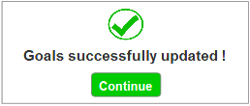

A-3

#A-2

Figure 1.8

This message is shown when user successfully update the goal.

**2) Tracking daily goals and keeping a log of daily activities**

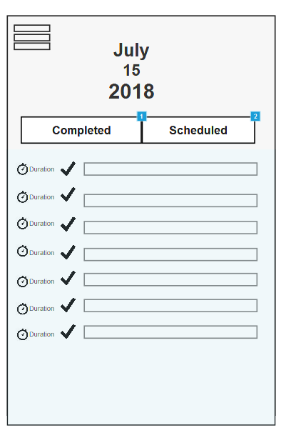

B-1

B-4

Figure 2.1

The main page of daily activities tracking is completed exercises that have been today. Each task is done within a duration and points are gained during the process to increase user virtual experience. The user is free to swipe up and down to see the tasks hidden below the screen.

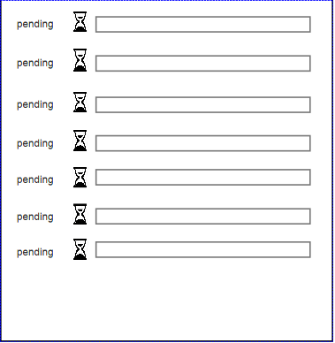

Figure 2.2

Once the user pressed on the scheduled tab, it will switch to a list of unfinished physical exercises. User just need to swipe up and down to look for a particular exercise that he interested in.

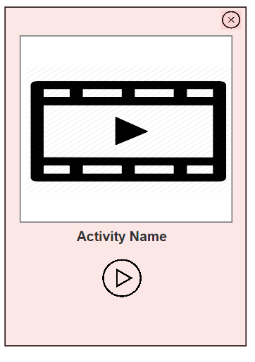

B-3

Figure 2.3

A pop up window will show up once the user press one of the activities from the list. Short video is prepared to instruct user to exercise properly to reduce soreness and avoid workout injuries. It may be a slideshow of guidelines and pictures. If the user felt that he is unsuitable / enter the wrong activity, he could just simply press the close button to return to the list of activities he saw just now. On the other hand, press the start button to execute the targeted activity.

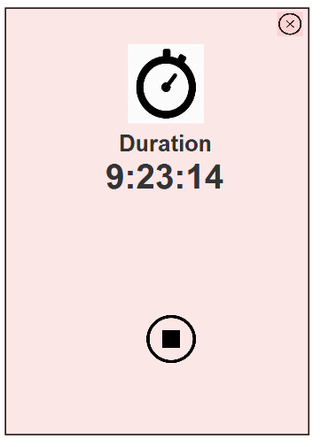

#B-5

B-4 (i)

#B-2

B-5

#B-5

Figure 2.4

The pop up window from Figure 2.3 will transit into a page with only a stop button which refers to completion of the activity given and timer calculating the time used for the targeted activity. A user could simply press the close button if he accidentally presses the start button previously or he wants to forfeit in the middle of it. Once the activity was done, it will go back to the page where a list of unfinished activities.

**3. Showing notification/ reminder for motivation**

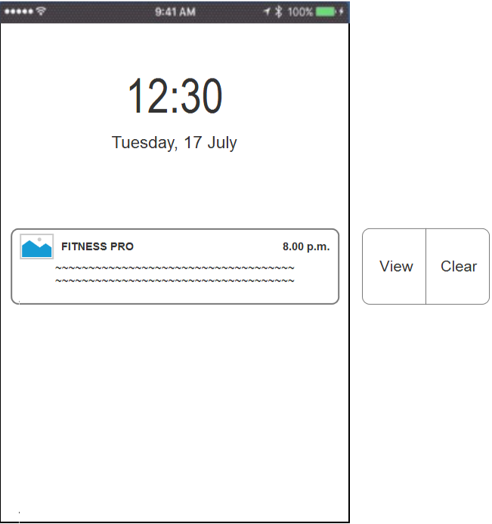

#C-1

C-1

Figure 3.1

This screen shows that a notification to remind user is received. User can choose to view the notification or clear the notification.

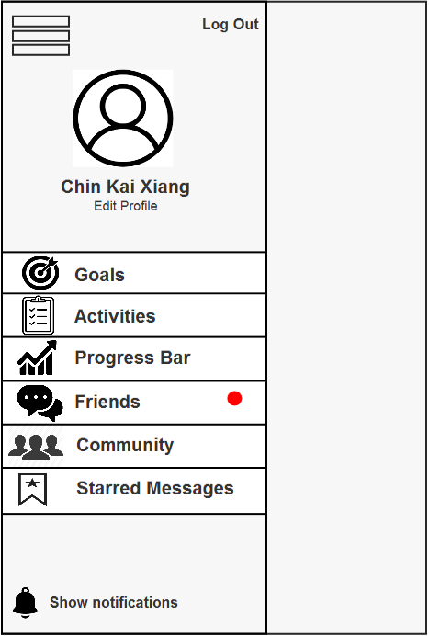

C-2

Figure 3.2

If user wants to turn on or off the notification then he/she can find that function at the bottom of the menu

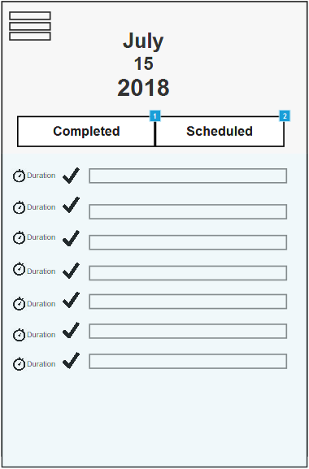

Figure 3.3

If user clicks the notification or presses the “View” button, then user will enters the system and straight go to the activities status screen.

**4) Visualizing the progress or showing important statistics**

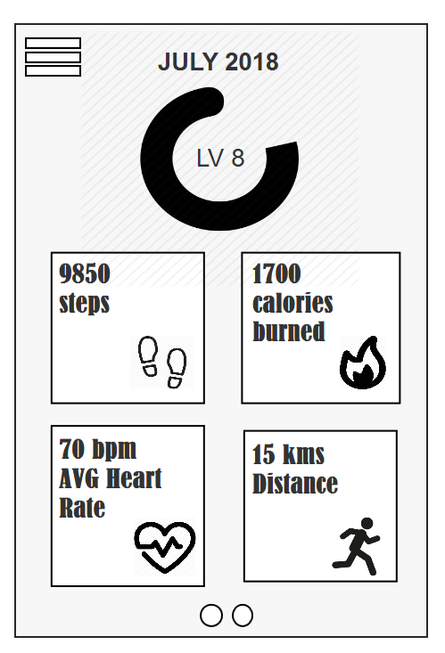

D-1 iv

D-1 iii

D-1 i

D-2 I & #D-2

D-1 ii

D-1 v

Figure 4.1

This screen shows progress bar of user virtual experience and significant updates could be seen because there will be colour difference at the progress bar, showing how much efforts the user put for the month. These 4 criteria is simplified and displayed graphically so that it is easily to be understood.

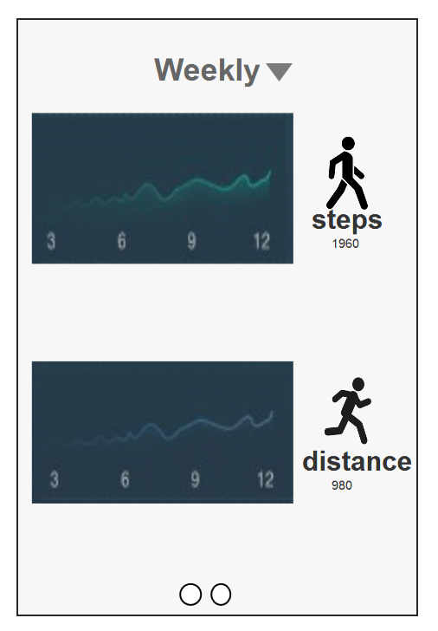

D-2 i & #D-2

D-2 ii

Figure 4.2

It happens when user swipe his screen to the left. Detailed statistics of each statistic are shown in the page by year, by month or by week.

**5) Inviting friends to the group for community and accountability to keep up the habit**

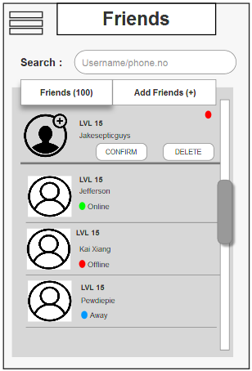

E-3 (ii)

E-2

#E-5

E-1 (i)

E-3 (i)

Figure 5.1

This screen shows the total number of added friends and online status of friends, provides the function on searching friend from friend list, and also shows the notification when there is a friend request.

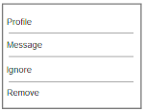

#E-3

Figure 5.2

This dialog provides the options on viewing friend profile (Figure 5.3), message friend (Figure 5.4), ignore and remove functions.

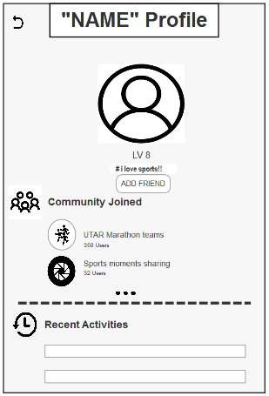

#E-5

E-2

(Existing group)

E-3 (iii)

Figure 5.3

This screen shows the profile or basic information of a user.

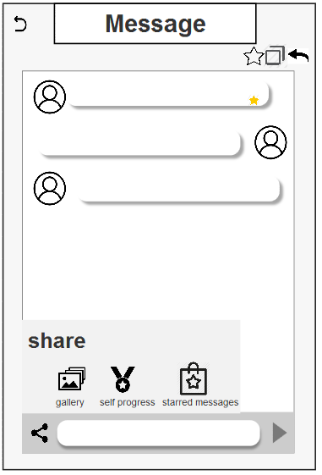

#E-5

#E-6

Figure 5.4

This screen lets the user to message his friend and provides sharing, recall, favourite, and copy functions in it.

When user hold the message, User can copy or recall a message.

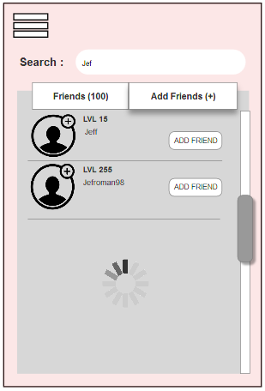

#E-2

(New group)

Figure 5.5

Same screen as figure 5.1 but with different tab selected, this screen lets the user to search, and add friends.

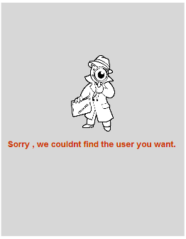

E-1 (ii)

#E-4

Figure 5.6

This dialog is popped out to notice user that you are entered a non-existent username or phone number.

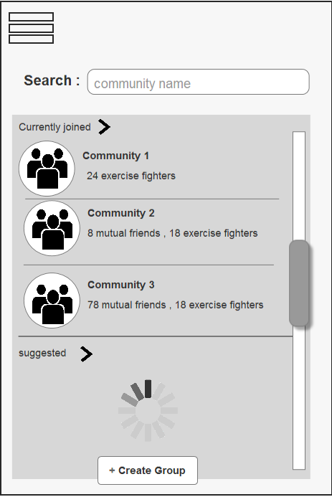

Figure 5.7

This screen shows the community group that the user has currently joined, provides the function on searching group from grouplist and creating group.

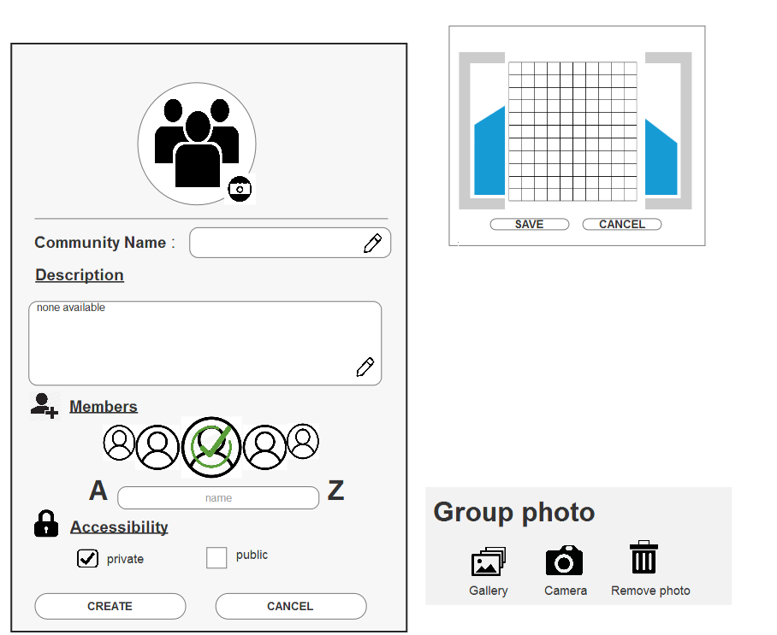

#E-5

#E-5

Figure 5.8

This screen shows the Create Community Group function, which user have to insert the photo, name, description, members, and accessibility of the community group. He only has the option to choose the group photo from images of phone’s gallery or images that taken by camera right on the spot.

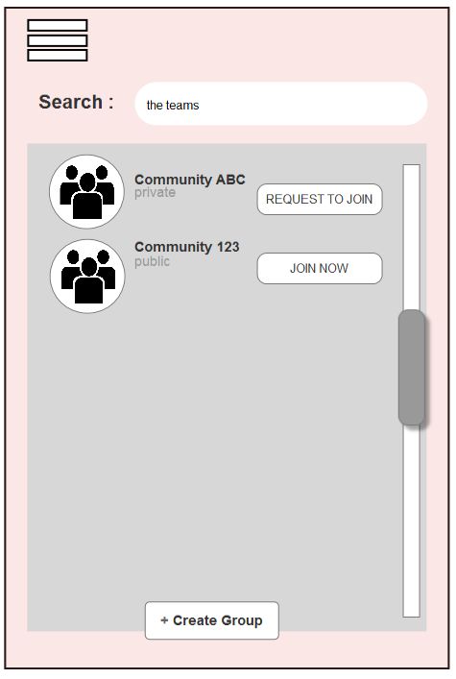

#E-2

Figure 5.9

Same screen as figure 6.1 but with different tab selected, this screen lets the user to search, request and join community group.

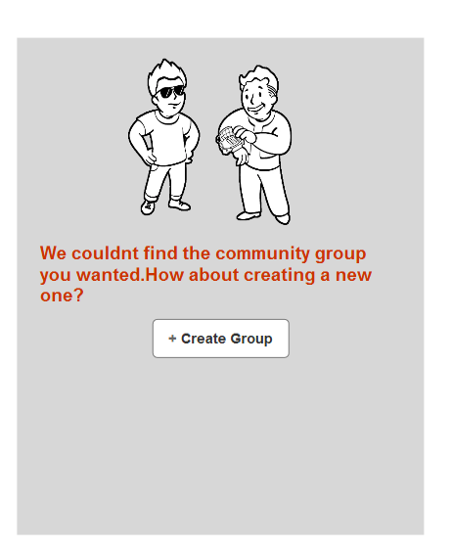

#E-4

Figure 5.10

This dialog is popped out to notice user that you are entered a non-existant community group name.

**6) Share result/experience challenges to the community group**

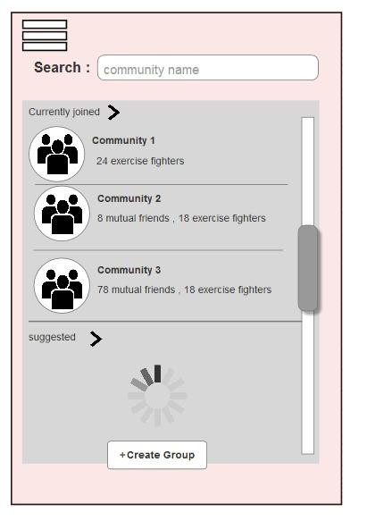

F-2

Step 1: Choose an existing group.

#F-4

During a search, all the possible groups are shown to help user recall.

Figure 6.1

This screen shows the community group that the user has currently joined, user can select the group he wish to interact with.

F-2 iii

After result shared, remain at this chat page.

F-2

Step 2 & 3: Share the result and press the send button.

F-3 & #F-3

F-4 & #F-3

#F-2

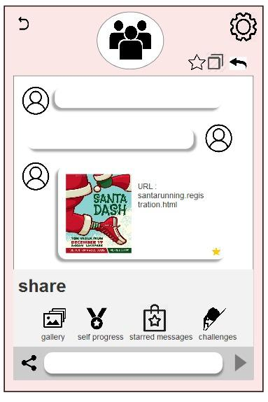

Figure 6.2

This screen lets the user to interact with his community group as it provides sharing self-progress, issue a challenge, recall, favourite, and copy functions. Setting icon for admin to configure the setup of the group or user who would like to quit the group or invite new user to group.

When user hold the message, User can copy, favourite or recall a message

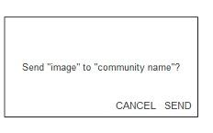

F-1 & #F-2

Figure 6.3

When the user click the send "self-progress button”, this message is prompted to ask if user confirms to send his self-progress to the community group.

**7) Other features**

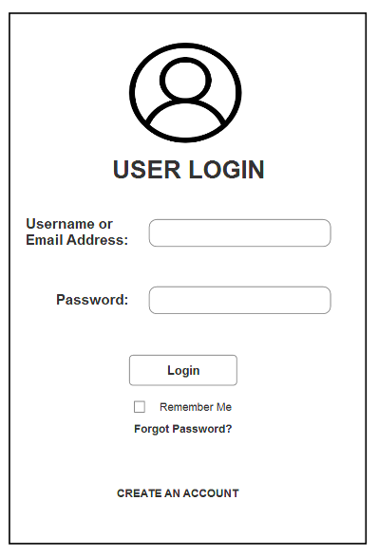

Figure 7.1

This is a screen layout where user can login his account. He needs to insert his username/email address, password to login. User can click the “remember me” option to remember his username/email address and password so he does not need to insert his login details next time. It also provide forgot password and create an account functions.

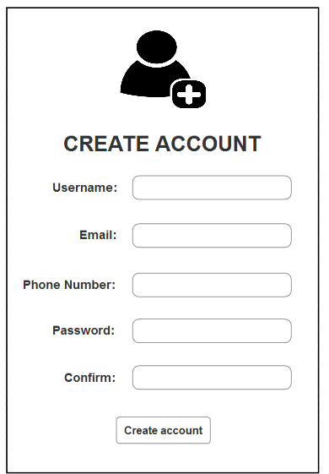

Figure 7.2

This is a screen layout where user can create his account. He needs to insert his username, email address, phone number, and password to create his account.

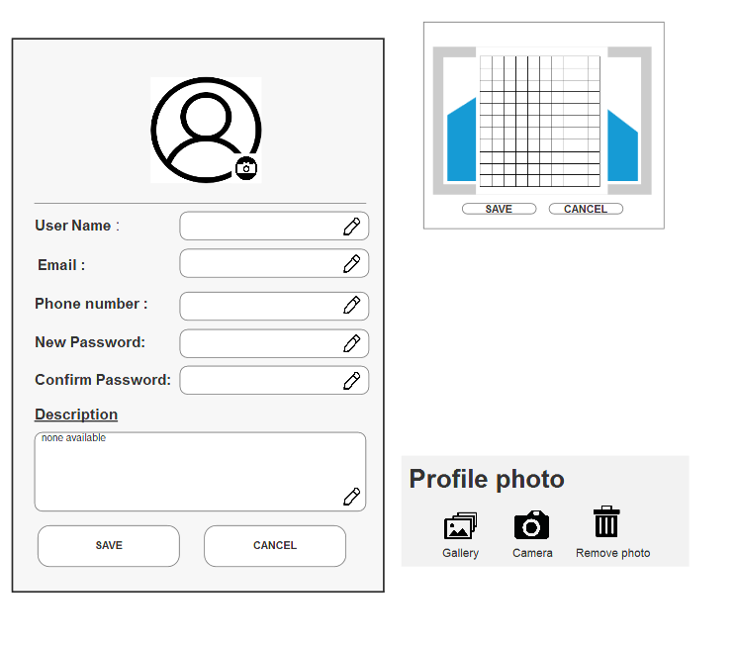

Figure 7.3

This is a screen layout where user can edit his profile. He only has the option to choose his profile pictures from images of phone’s gallery or images that taken by camera right on the spot.

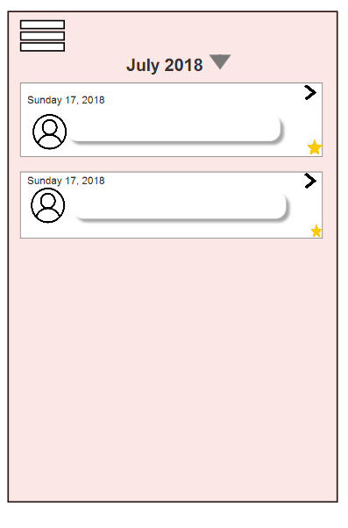

Figure 7.4

This is where all the starred messages are stored. User have to choose the month with a specific year he wanted to check on. By pressing the selected starred message, the screen will move to the selected conversation automatically.

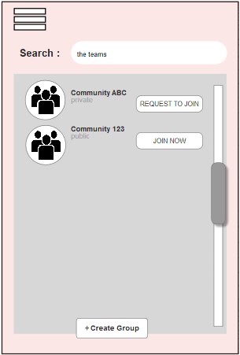

Figure 7.5

User can choose to join other community.

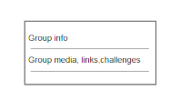

Figure 7.6

User can choose what to do at the setting button at the top corner of the group chat.

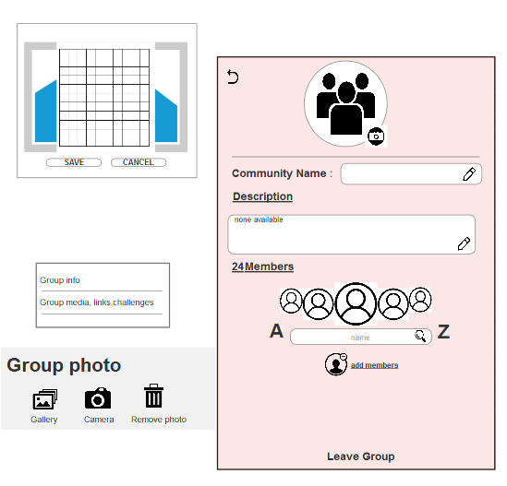

Figure 7.7

Once the user is a part of member of the community, he can alter some of group info. If he is an admin, he can add members, this is where he can invite his new added friend to the community.



Figure 7.8

This is where all the data is stored based on 3 folders: media, links and ongoing or completed challenges done by user himself or other user.

**Task 2**

Relate the screen sketches (low-fidelity (paper) prototype) to the Schneiderman’s Eight golden rules as fol

1. Strive for consistency

2. Enable frequent users to use shortcuts / [Cater to universal usability]

3. Offer informative feedback

4. Design dialogs to yield closure

5. Prevent errors

6. Permit easy reversal of actions

7. Support internal locus of control

8. Reduce short term memory load

Based on the screen sketches, relate the design to the Eight golden rules. Example is shown in Table A (below).

Table A

|  |  |  |
| --- | --- | --- |
| **Functions** | **8 golden rules** | **Screen as label** |
| Setting goal | 1. 1. Strive for consistency | #A-1 |
|  | 2. 2. Offer informative feedback | #A-2 |
|  | 3. 3. Design dialogs to closure | #A-3 |
|  | 4. 4. Prevent errors | #A-4 |
|  | 5. 5. Permit easy reversal of actions | #A-5 |
|  | 6. 6. Support internal locus of control | #A-6 |
| Tracking daily goals and             keeping a log of daily activities | 1. Strive for consistency | #B-1 |
|  | 2. Offer informative feedback | #B-2 |
|  | 3. Design dialogs to yield closure | #B-3 |
|  | 4. Permit easy reversal of actions | #B-4 |
|  | 5. Support internal locus of control | #B-5 |
|  | 6. Reduce short term memory load | #B-6 |
| Showing notification/ reminder             for motivation | 1. Strive for consistency | #C-1 |
|  | 2. Offer informative feedback | #C-2 |
| Visualizing the progress or             showing important statistics | 1. Strive for consistency | #D-1 |
|  | 2. Support internal locus of control | #D-2 |
|  | 3. Reduce short term memory load | #D-3 |
| Inviting friends to group for             community | 1. Strive for consistency | #E-1 |
|  | 2. Offer informative feedback | #E-2 |
|  | 3. Design dialogs to yield closure | #E-3 |
|  | 4. Prevent errors | #E-4 |
|  | 5. Support internal locus of control | #E-5 |
|  | 6. Reduce short-term memory loss | #E-6 |
| Share result/experience of the             challenges to the community             group | 1. Strive for consistency | #F-1 |
|  | 2. Support internal locus of control | #F-2 |
|  | 3. Permit easy reversal of actions | #F-3 |

**Task 3**

|  |  |  |  |  |  |  |  |  |  |  |
| --- | --- | --- | --- | --- | --- | --- | --- | --- | --- | --- |
| **Functions/ Patterns** | **Undo** | **Abort** | **Step-by-step** | **Progress Feedback** | **System status feedback** | **Warning** | **Multi-level help** | **Preferences** | **Favourites** | **Structured text entry** |
| i) Setting goal | **√** | **√** | **√** |  | **√** |  |  |  |  |  |
| ii) Tracking daily goals and keeping a log of daily activities |  | **√** | **√** | **√** | **√** |  | **√** |  |  |  |
| iii) Showing notification/ reminder for motivation |  |  |  |  | **√** | **√** |  | **√** |  |  |
| iv) Visualising the progress or showing important statistics |  |  | **√** |  | **√** |  |  |  |  |  |
| v) Inviting friends to the group for community and accountability to keep up the habit |  |  | **√** |  | **√** |  |  |  |  | **√** |
| vi) Share result/ experience of challenges to the community group for encouragement | **√** | **√** | **√** |  |  |  |  |  | **√** |  |

### **Usability specifications**

|  |  |  |  |
| --- | --- | --- | --- |
| **Functions** | **Patterns Selected** | **Usability Specifications** | **Label** |
| **A) Setting goal** | 1. Abort | i.The Setting Goal Function shall allow user to exit while pressing the Cancel Button.  ii.When the Cancel button is clicked, a confirmation message shall be shown to user and ask them to confirm the action. | A-1 |
| 2.Step-by-step | i. The Setting Goal Function shall have 3 steps.  ii.The list of steps are selecting fitness activity,setting the difficulty of each activity and confirming the goal.  iii. The Setting Goal Function shall be able to return to its previous step by pressing the back button. | A-2 |
| 3.System status feedback | i. The Setting Goal Function shall be able to notify user when the setting task is completed.  ii. The system status information shall be presented in highlighted but non-obtrusively format upon the completion of task. | A-3 |
| 4. Undo | i.  The Setting Goal Function which comprises of three steps shall allow user to undo a particular step if user wants to modify the step.  ii. The Setting Goal Function shall allow user to redo a particular step if user wants to restore the data filled. | A-4 |
| **B) Tracking daily goals and keeping a log of daily activities** | 1.System status Feedback | i. System shall updates frequently and list out scheduled tasks and completed tasks. | B-1 |
| 2.Step-by-Step | i. The Tracking Daily Goals Function shall be able to allow user to navigate between different pages which show the current status of various activities.  ii. The Tracking Daily Goals Function shall be able to inform user about the current selected page within the navigable pages.  iii. The Tracking Daily Goals Function shall allow user to traverse steps in reverse within the navigable pages. | B-2 |
| 3.Multilevel help | i. The Tracking Daily Goals Function shall attach a tutorial video/slide show in the selected daily goal. | B-3 |
| 4.Progress Feedback | i. The Tracking Daily Goals Function shall be able to show the fitness tracking progress by recording the durations of activity.  ii. The Tracking Daily Goals Function shall be able to list out all the scheduling tasks and completed tasks.  iii. The Tracking Daily Goals Function shall be able to set the scheduling tasks to completed tasks after completing the task.  Iv. The Tracking Daily Goals Function shall be able to pop up a window of selected exercise. | B-4 |
| 5. Abort | i. The Tracking Daily Goals Function shall allow user to go back to previous page after clicking wrongly. | B-5 |
| **C) Showing notification/ reminder for motivation** | 1. System Status Feedback | i. The Showing Notification Function shall be able to notify user about the system status which is the current status of daily goals at 7.00 a.m. and 5.00 p.m. everyday.  ii. The current status of daily goals shall be presented in highlighted but non-obtrusive format.  Iii.  The current status of daily goals shall be presented as a notification message placed on the top section on the mobile phone’s screen. | C-1 |
| 2. Warning | i. The Showing Notification Function shall be able to display notification about the current status of daily goals.  ii. The current status of daily goals shall be presented in highlighted but non-obtrusive format which can be removed. | C-2 |
|  | 3. Preferences | ~~i. The Showing Notification Function shall be able to allow user to turn on or off the notification, set the importance of notification and customize the notification format.~~  ~~ii. The user specific preferences shall be presented in format of a description of a preference plus tickable box for which can be found in the setting page.~~  ~~iii. The Showing Notification Function shall be able to provide default values for each preference so that user can reset at any time.~~  **New:**  **i. The Showing Notification Function shall be able to allow user to turn on or off the notification which can be found at the bottom of the menu.**  Reason:  Although the old specifications allow more flexible control over notification settings but it’s hard for novice users to use as they may not know how to customize all these settings (they may just want to turn off the notification). Therefore, to allow the ease of use. The system will only let user to turn on or off the notification. | C-3  This pattern was changed. |
| **D) Visualising the progress or showing important statistics** | 1.System Feedback | i. The Data Visualisation function shall display total distance travelled in unit of KM.  ii. The Data Visualisation function shall display total calories burnt throughout the month.  iii. The Data Visualisation function shall display total walking steps throughout the month.  iv. The Data Visualisation function shall show average heart rate with the unit of BPM.  v. The Data Visualisation function shall be able to notify user by showing a significant increase which is highlighted and numbered in the user experience status bar for the whole week. | D-1 |
| 2.Step-by-Step | i. The Data Visualisation function shall be able to allow user to navigate between different pages which show the statistical progress for month and a simple summary of the monthly progress.  ii. The Data Visualisation function shall let the user to choose either to display total progress daily/weekly/monthly with a statistical diagram showing the progress of several activities.  ~~iii. The system shall provide a button that can print screen.~~  Reason:  The system will automatically print screen when the user wants to share their self progress (by pressing the "self progress" button). | D-2  Pattern D-2 iii  was  removed. |
| **E) Inviting friends to the group for community and accountability to keep up the habit** | 1.Structured Text Entry | i. The Friends Inviting Function shall display the result of searching while user enter the valid username or phone.no. **√**  ii. The Friends Inviting Function shall be able to display an invalid notification when user has entered an invalid or non-existent username or phone. no.**√** | E-1 |
| 2.Step By Step | I.  The Friends Inviting Function shall have 4 steps.  ii. The list of steps are add friend, sending request/receive request, and confirming the friend request, create community group (User add member while creating group).  ~~ii. The Friends Management Function shall be able to let user to check info, message friend, ignore, and remove friend.~~  ~~iii. The Friends Management Function shall be able to let user to view friend info in another page. (Eg. Info page)~~  ~~iv. The Friends Management Function shall be able to allow user to chat with friend in another page. (Eg. Chatting page)~~  ~~v.  The Friends Management Function shall be able to let user to block message from friends.~~  ~~vi. The Friends Management Function shall be able to let user to remove or unfollow friends.~~  **Reason: unrelated to friends inviting function.** | E-2 |
| 3.System Status Feedback | i. The system shall be able to notify user the total number of added friends.  ii. The system shall be able to notify user and display the online status of added friends.  iii. The system shall be able to display the level ranking and fitness progress of added friends. | E-3 |
| **F) Share result/ experience of challenges to the community group for encouragement** | 1. Abort | i.The Share Result Function shall allow user to cancel the sending result progress by pressing outside the share result function button. | F-1 |
| 2.Step-by-step | i. The Share Result Function shall have 3 steps.  ii. The list of steps are selecting an existing group, share result/challenges and confirming the action.  iii. The Share Result Function shall be able to return to its current chatting group. | F-2 |
| 3.Favourites | i. User are able to add his/her favourite message in starred messages database by clicking the star icon on top of the conversation. | F-3 |
| 4.Undo | i. The Share Result Function shall allow users to undo his/her message if his/her accidentally sends a typo/wrong message. | F-4 |